Modeling change in occurrence and distribution dynamics using dynamic site-occupancy models

Module 11

Patuxent workshop
2–5 April 2012

11.1. Introduction to the modeling of occurrence and species distributions
Why ?
(1) interested in occupancy, but lack of closure is a problem. Must break total sampling period apart into pieces within which closure and model change in between.
(2) Much more often, focus of interest is directly on the dynamics ! Dynamic site-occupancy model (MacKenzie et al. 2003) represents a very flexible and powerful model for distribution dynamics
Essentially a generalized metapopulation model, where the generalization means the accommodation of detection probabilityt

11.2. Model description
As a summary, here is the simplest dynamic site-occupancy model written in algebra. We drop the site index (i) for increased readability and denote by time by t:
1A. Initial state: 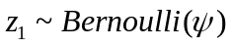
1B. State dynamics: 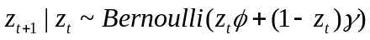 # note if-else
2. Observation process: 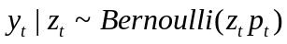
Model can be parameterized in terms of survival (), as we do here (and as we did in Royle & Kéry 2007) or in terms of its complement, extinction probability (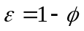), as does everybody else, e.g., MacKenzie et al. 2003, as well as the software PRESENCE and unmarked.
The main assumptions of the site-occupancy model are these:
1. Closure assumption: As before, but only within each primary period
2. No false positive errors: same as before
3. Independence of detection: ditto
4. Homogeneity of detection at the M sites: same
5. Parametric assumptions: same as before

11.3. Data simulation and analysis in unmarked and BUGS/JAGS
We define a function to generate a data set. As always, apart from generating a data set to be analyzed later, this function may be used to get insights into the structure of the model used to analyze the data, issues of parameter estimation or required samples sizes.

data.fn <- function(R = 250, J = 3, K = 10, psi1 = 0.4, range.p = c(0.2, 0.4), range.phi = c(0.6, 0.8), range.gamma = c(0, 0.1)) {
# Function to simulate detection/nondetection data for dynamic site-occ model
# Annual variation in probabilities of patch survival, colonization and
# detection is specified by the bounds of a uniform distribution.

# Function arguments:
# R – Number of sites
# J – Number of replicate surveys
# K – Number of years
# psi1 – occupancy probability in first year
# range.p – bounds of uniform distribution from which annual p drawn
# range.psi and range.gamma – same for survival and colonization probability

# Set up some required arrays
site <- 1:R # Sites
year <- 1:K # Years
psi <- rep(NA, K) # Occupancy probability
muZ <- z <- array(dim = c(R, K)) # Expected and realized occurrence
y <- array(NA, dim = c(R, J, K)) # Detection histories

# Determine initial occupancy and demographic parameters
psi[1] <- psi1 # Initial occupancy probability
p <- runif(n = K, min = range.p[1], max = range.p[2])
phi <- runif(n = K-1, min = range.phi[1], max = range.phi[2])
gamma <- runif(n = K-1, min = range.gamma[1], max = range.gamma[2])

# Generate latent states of occurrence
# First year
z[,1] <- rbinom(R, 1, psi[1]) # Initial occupancy state
# Later years
for(i in 1:R){ # Loop over sites
for(k in 2:K){ # Loop over years
muZ[k] <- z[i, k-1]*phi[k-1] + (1-z[i, k-1])*gamma[k-1] # Prob for occ.
z[i,k] <- rbinom(1, 1, muZ[k])
}
}

# Plot realised occupancy
plot(year, apply(z, 2, mean), type = "l", xlab = "Year", ylab = "Occupancy or Detection prob.", col = "red", xlim = c(0,K+1), ylim = c(0,1), lwd = 2, lty = 1, frame.plot = FALSE, las = 1)
lines(year, p , type = "l", col = "red", lwd = 2, lty = 2)

# Generate detection/nondetection data
for(i in 1:R){
for(k in 1:K){
prob <- z[i,k] * p[k]
for(j in 1:J){
y[i,j,k] <- rbinom(1, 1, prob)
}
}
}

# Compute annual population occupancy
for (k in 2:K){
psi[k] <- psi[k-1]*phi[k-1] + (1-psi[k-1])*gamma[k-1]
}

# Plot apparent occupancy
psi.app <- apply(apply(y, c(1,3), max), 2, mean)
lines(year, psi.app, type = "l", col = "black", lwd = 2)
text(0.85*K, 0.06, labels = "red solid – true occupancy\n red dashed – detection\n black – observed occupancy")

# Return data
return(list(R = R, J = J, K = K, psi = psi, psi.app = psi.app, z = z, phi = phi, gamma = gamma, p = p, y = y))
}

We execute the function once to obtain a data set for 250 owl territories with three surveys in each of 10 years (Fig. 11–1).

data <- data.fn(R = 250, J = 3, K = 10, psi1 = 0.6, range.p = c(0.1, 0.9), range.phi = c(0.7, 0.9), range.gamma = c(0.1, 0.5))
str(data)
> str(data)
List of 10
$ R : num 250
$ J : num 3
$ K : num 10
$ psi : num [1:10] 0.6 0.647 0.647 0.68 0.653 ...
$ psi.app: num [1:10] 0.348 0.668 0.62 0.232 0.628 0.248 0.52 0.18 0.508
$ z : num [1:250, 1:10] 0 1 1 1 1 1 1 1 1 1 ...
$ phi : num [1:9] 0.774 0.796 0.783 0.751 0.843 ...
$ gamma : num [1:9] 0.458 0.374 0.491 0.445 0.245 ...
$ p : num [1:10] 0.228 0.836 0.812 0.149 0.805 ...
$ y : num [1:250, 1:3, 1:10] 0 0 0 0 0 0 0 0 1 0 ...

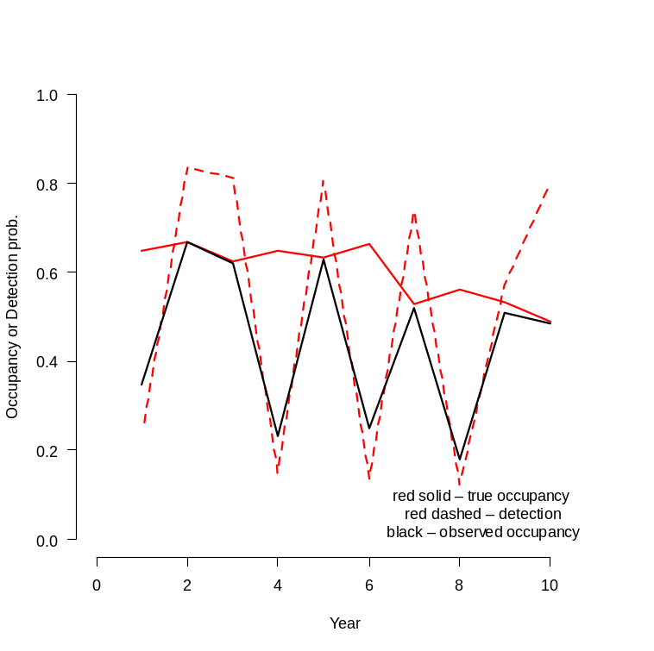
Fig. 11–1: Simulated dynamic occupancy data.
We use the unmarked function colext to fit the basic, fully time-dependent dynamic occupancy model. The model fitting function in unmarked for dynamic occupancy models is called colext() (from colonization-extinction). The analysis requires us to format the data in a function-specific way. There is a tutorial (called a vignette) on the use of this function available at http://cran.r-project.org/web/packages/unmarked/index.html. The following text copies much from there.

library(unmarked) # Load the package

Next, we reformat the detection/non-detection data from a 3-dimensional array (as generated) into a 2-dimensional matrix with M rows. That is, we put the annual tables of data (the slices of the former 3-D array) “sideways” to produce a "wide" layout of the data.

yy <- matrix(data$y, data$R, data$J* data$K)
str(yy)
num [1:250, 1:30] 0 0 0 0 0 0 0 0 1 0 ...

Next, we create a matrix indicating the year each site was surveyed.

year <- matrix(c('01','02','03','04','05','06','07','08','09','10'),
nrow(yy), data$K, byrow=TRUE)
head(year)
> head(year)
[,1] [,2] [,3] [,4] [,5] [,6] [,7] [,8] [,9] [,10]
[1,] "01" "02" "03" "04" "05" "06" "07" "08" "09" "10"
[2,] "01" "02" "03" "04" "05" "06" "07" "08" "09" "10"
[3,] "01" "02" "03" "04" "05" "06" "07" "08" "09" "10"
[4,] "01" "02" "03" "04" "05" "06" "07" "08" "09" "10"
[5,] "01" "02" "03" "04" "05" "06" "07" "08" "09" "10"
[6,] "01" "02" "03" "04" "05" "06" "07" "08" "09" "10"

To organize the data in the format required by colext, we make use of the function unmarkedMultFrame(). The only required arguments are y, the detection/non-detection data, and numPrimary, the number of seasons. Three types of covariates can be supplied using the arguments siteCovs, yearlySiteCovs, and obsCovs. In this case, we only make use of the second type, which must have R rows and K columns.

simUMF <- unmarkedMultFrame(
y = yy,
yearlySiteCovs = list(year = year),
numPrimary=data$K)
summary(simUMF)

unmarkedFrame Object

250 sites
Maximum number of observations per site: 30
Mean number of observations per site: 30
Number of primary survey periods: 10
Number of secondary survey periods: 3
Sites with at least one detection: 243

Tabulation of y observations:
0 1 <NA>
5197 2303 0

Yearly-site-level covariates:
year
01 : 250
02 : 250
03 : 250
04 : 250
05 : 250
06 : 250
(Other):1000

Next, we fit a series of dynamic occupancy models that make different assumptions about the annual variation (or lack thereof) in the parameters. We will then use AIC to tell us which model best describes the data set.
Note that by default, in R a factor such as year here is a parameterized in terms of an intercept and effects representing differences. This would mean that the parameter for the first year is the intercept and the effects would denote the differences between the parameter values in all other years, relative to the parameter value in the first year, which serves as a reference level or baseline. This treatment or effects parameterization is useful for testing for differences. For simple presentation, a means parameterization is more practical, where each parameter directly has the meaning of the year-specific parameter. A means parameterization can be specified by adding a -1 to the formula for the time-dependent parameters.
We fit all possible combinations of time-dependence or constancy over time. So we make this a little exercise of using simulation to see how well AIC performs. Note that all we are interested at first is model comparison using AIC, we could speed up computation by requesting the se not to be computed (i.e., setting se = FALSE) and by providing ‘informed’ initial values. For the latter, we could use those from a neighbouring model.

fm1 <- colext(psiformula = ~1, # First-year occupancy
gammaformula = ~ 1, # Colonization
epsilonformula = ~ 1, # Extinction
pformula = ~ 1, # Detection
data = simUMF)

system.time(summary(fm2 <- colext(psiformula=~1, gammaformula=~year-1,
epsilonformula=~1, pformula =~1, data = simUMF,
control=list(trace=TRUE, REPORT=1, maxit = 500), se = TRUE)))

system.time(summary(fm3 <- colext(psiformula=~1, gammaformula=~1,
epsilonformula=~year-1, pformula =~1, data = simUMF,
control=list(trace=TRUE, REPORT=1, maxit = 500), se = TRUE)))

system.time(summary(fm4 <- colext(psiformula=~1, gammaformula=~1,
epsilonformula=~1, pformula =~ year-1, data = simUMF,
control=list(trace=TRUE, REPORT=1, maxit = 500), se = TRUE)))

system.time(summary(fm5 <- colext(psiformula=~1, gammaformula=~year-1,
epsilonformula=~year-1, pformula =~1, data = simUMF,
control=list(trace=TRUE, REPORT=1, maxit = 500), se = TRUE)))

system.time(summary(fm6 <- colext(psiformula=~1, gammaformula=~year-1,
epsilonformula=~1, pformula =~year-1, data = simUMF,
control=list(trace=TRUE, REPORT=1, maxit = 500), se = TRUE)))

system.time(summary(fm7 <- colext(psiformula=~1, gammaformula=~1,
epsilonformula=~year-1, pformula =~year-1, data = simUMF,
control=list(trace=TRUE, REPORT=1, maxit = 500), se = TRUE)))

system.time(summary(fm8 <- colext(psiformula=~1, gammaformula=~year-1,
epsilonformula=~year-1, pformula =~year-1, data = simUMF,
control=list(trace=TRUE, REPORT=1, maxit = 500), se = TRUE)))

And what about a model with time-dependence in the psiformula ?
We generate the fit list and then compare the models.

models <- fitList(
'psi(.)gam(.)eps(.)p(.)' = fm1,
'psi(.)gam(Y)eps(.)p(.)' = fm2,
'psi(.)gam(.)eps(Y)p(.)' = fm3,
'psi(.)gam(.)eps(.)p(Y)' = fm4,
'psi(.)gam(Y)eps(Y)p(.)' = fm5,
'psi(.)gam(Y)eps(.)p(Y)' = fm6,
'psi(.)gam(.)eps(Y)p(Y)' = fm7,
'psi(.)gam(Y)eps(Y)p(Y)' = fm8)
(ms <- modSel(models))
> (ms <- modSel(models))
nPars AIC delta AICwt cumltvWt
psi(.)gam(.)eps(.)p(Y) 13 6400.55 0.00 6.5e-01 0.65
psi(.)gam(Y)eps(.)p(Y) 21 6401.91 1.37 3.3e-01 0.98
psi(.)gam(.)eps(Y)p(Y) 21 6408.15 7.60 1.5e-02 0.99
psi(.)gam(Y)eps(Y)p(Y) 29 6409.37 8.83 7.9e-03 1.00
psi(.)gam(Y)eps(Y)p(.) 20 7041.88 641.33 3.5e-140 1.00
psi(.)gam(.)eps(Y)p(.) 12 7189.38 788.84 3.3e-172 1.00
psi(.)gam(Y)eps(.)p(.) 12 7263.52 862.97 2.6e-188 1.00
psi(.)gam(.)eps(.)p(.) 4 7415.94 1015.39 2.1e-221 1.00
Warnmeldung:
In sqrt(diag(vcov(x, altNames = TRUE))) : NaNs wurden erzeugt

We see that the huge variability in annual detection “tricked” the AIC in pointing out a model with constant parameters except for detection. Also, any model that does not have time-dependent detection has such a huge difference in AIC that one might at first wonder whether these models have actually converged (NOTE: This may happen with this kind of model.) Also, some Hessian matrix was singular, so NaNs were generated when trying to invert them (is this correct ?).
Now before we look at predictions and parameter estimates, we want to fit the model Bayesianly and then compare the estimates. We conduct the analysis using code from Royle and Kéry (2007), which includes estimation of the actual number of occupied territories (among the 250), the occupancy-based population growth rate and the turnover rate; see there for a definition of these terms and much more info. We find it convenient to organize the data in a three-dimensional array, where the dimensions represent sites, (within-year) replicates and years. Therefore, we use for the Bayesian analysis using BUGS the data in the original three-dimensional format. We will only fit the fully time-dependent model.

# Bundle data
win.data <- list(y = data$y, nsite = dim(data$y)[1], nrep = dim(data$y)[2], nyear = dim(data$y)[3])

# Specify model in BUGS language
sink("Dynocc.txt")
cat("
model {

# Specify priors
psi1 ~ dunif(0, 1)
for (k in 1:(nyear-1)){
phi[k] ~ dunif(0, 1)
gamma[k] ~ dunif(0, 1)
p[k] ~ dunif(0, 1)
}
p[nyear] ~ dunif(0, 1)

# Ecological submodel: Define state conditional on parameters
for (i in 1:nsite){
z[i,1] ~ dbern(psi1)
for (k in 2:nyear){
muZ[i,k]<- z[i,k-1]*phi[k-1] + (1-z[i,k-1])*gamma[k-1]
z[i,k] ~ dbern(muZ[i,k])
} #k
} #i

# Observation model
for (i in 1:nsite){
for (j in 1:nrep){
for (k in 1:nyear){
muy[i,j,k] <- z[i,k]*p[k]
y[i,j,k] ~ dbern(muy[i,j,k])
} #k
} #j
} #i

# Derived parameters: Sample and population occupancy, growth rate and turnover
psi[1] <- psi1
n.occ[1]<-sum(z[1:nsite,1])
for (k in 2:nyear){
psi[k] <- psi[k-1]*phi[k-1] + (1-psi[k-1])*gamma[k-1]
n.occ[k] <- sum(z[1:nsite,k])
growthr[k-1] <- psi[k]/psi[k-1]
turnover[k-1] <- (1 - psi[k-1]) * gamma[k-1]/psi[k]
}
}
",fill = TRUE)
sink()

# Initial values
zst <- apply(data$y, c(1, 3), max) # Observed occurrence as inits for z
inits <- function(){ list(z = zst)}

# Parameters monitored
params <- c("psi", "phi", "gamma", "p", "n.occ", "growthr", "turnover")

# MCMC settings
ni <- 2500
nt <- 4
nb <- 500
nc <- 3

# Call WinBUGS from R (ART 3 min)
out1 <- bugs(win.data, inits, params, "Dynocc.txt", n.chains = nc, n.thin = nt, n.iter = ni, n.burnin = nb, debug = TRUE, bugs.directory = bugs.dir, working.directory = getwd())

# Summarize posteriors from WinBUGS
print(out1, dig = 2)
Inference for Bugs model at "Dynocc.txt", fit using WinBUGS,
3 chains, each with 2500 iterations (first 500 discarded), n.thin = 4
n.sims = 1500 iterations saved
mean sd 2.5% 25% 50% 75% 97.5% Rhat n.eff
psi[1] 0.75 0.08 0.59 0.70 0.75 0.81 0.88 1.01 170
psi[2] 0.67 0.03 0.62 0.65 0.67 0.69 0.73 1.00 1500
psi[3] 0.62 0.03 0.56 0.60 0.63 0.65 0.69 1.00 1500
psi[4] 0.61 0.10 0.42 0.54 0.61 0.68 0.80 1.00 1200
psi[5] 0.63 0.03 0.57 0.61 0.63 0.65 0.69 1.00 1500
psi[6] 0.71 0.06 0.58 0.67 0.72 0.75 0.82 1.00 1500
psi[7] 0.53 0.03 0.47 0.51 0.53 0.55 0.59 1.00 1100
psi[8] 0.55 0.09 0.38 0.49 0.55 0.61 0.73 1.01 1500
psi[9] 0.54 0.03 0.48 0.52 0.54 0.57 0.61 1.00 1500
psi[10] 0.49 0.03 0.43 0.46 0.49 0.51 0.55 1.00 1500
phi[1] 0.80 0.04 0.71 0.77 0.80 0.83 0.88 1.01 440
phi[2] 0.77 0.03 0.70 0.75 0.77 0.79 0.83 1.00 640
phi[3] 0.69 0.11 0.47 0.61 0.69 0.77 0.88 1.00 630
phi[4] 0.80 0.05 0.69 0.77 0.80 0.84 0.89 1.00 1200
phi[5] 0.89 0.07 0.74 0.85 0.90 0.94 0.99 1.00 890
phi[6] 0.69 0.05 0.59 0.65 0.69 0.72 0.78 1.01 270
phi[7] 0.76 0.11 0.52 0.70 0.77 0.83 0.96 1.01 700
phi[8] 0.77 0.06 0.64 0.73 0.77 0.81 0.88 1.00 1500
phi[9] 0.70 0.04 0.63 0.68 0.70 0.73 0.78 1.00 1500
gamma[1] 0.27 0.15 0.02 0.16 0.28 0.38 0.54 1.03 210
gamma[2] 0.33 0.05 0.23 0.29 0.32 0.36 0.43 1.01 220
gamma[3] 0.48 0.12 0.27 0.39 0.48 0.58 0.71 1.00 1500
gamma[4] 0.34 0.13 0.07 0.25 0.37 0.44 0.56 1.00 1500
gamma[5] 0.40 0.09 0.23 0.34 0.40 0.45 0.57 1.00 1500
gamma[6] 0.14 0.08 0.01 0.07 0.13 0.19 0.31 1.00 1500
gamma[7] 0.31 0.09 0.15 0.25 0.30 0.37 0.52 1.00 690
gamma[8] 0.26 0.09 0.07 0.20 0.27 0.32 0.43 1.01 870
gamma[9] 0.23 0.04 0.15 0.20 0.22 0.26 0.31 1.00 1500
p[1] 0.19 0.02 0.14 0.17 0.18 0.20 0.24 1.01 250
p[2] 0.80 0.02 0.76 0.79 0.80 0.81 0.83 1.00 1300
p[3] 0.81 0.02 0.77 0.80 0.81 0.82 0.84 1.00 1500
p[4] 0.15 0.03 0.10 0.13 0.15 0.17 0.22 1.00 860
p[5] 0.81 0.02 0.77 0.79 0.81 0.82 0.84 1.00 1500
p[6] 0.14 0.02 0.11 0.13 0.14 0.15 0.18 1.00 1500
p[7] 0.75 0.02 0.70 0.74 0.75 0.77 0.79 1.01 300
p[8] 0.14 0.03 0.09 0.11 0.13 0.15 0.20 1.00 1200
p[9] 0.58 0.03 0.52 0.56 0.58 0.60 0.63 1.00 780
p[10] 0.82 0.02 0.78 0.81 0.83 0.84 0.86 1.00 750
n.occ[1] 188.04 18.16 151.00 176.00 190.00 201.00 220.00 1.01 180
n.occ[2] 168.44 1.23 167.00 168.00 168.00 169.00 171.00 1.00 1500
n.occ[3] 156.15 1.13 155.00 155.00 156.00 157.00 159.00 1.00 1500
n.occ[4] 152.90 24.49 106.00 135.00 153.00 171.00 198.00 1.00 1100
n.occ[5] 158.23 1.19 157.00 157.00 158.00 159.00 161.00 1.00 1500
n.occ[6] 178.21 14.22 147.47 169.00 180.00 189.00 202.00 1.00 800
n.occ[7] 132.21 1.67 130.00 131.00 132.00 133.00 136.00 1.00 1500
n.occ[8] 138.07 21.23 95.00 124.00 138.00 152.25 179.00 1.01 1500
n.occ[9] 136.48 3.78 130.00 134.00 136.00 139.00 145.00 1.00 1500
n.occ[10] 121.73 0.87 121.00 121.00 122.00 122.00 124.00 1.00 1500
growthr[1] 0.91 0.10 0.75 0.83 0.89 0.96 1.13 1.01 170
growthr[2] 0.93 0.05 0.84 0.90 0.93 0.96 1.02 1.00 1500
growthr[3] 0.98 0.17 0.66 0.86 0.98 1.10 1.29 1.00 1000
growthr[4] 1.06 0.19 0.78 0.92 1.03 1.18 1.51 1.00 940
growthr[5] 1.13 0.10 0.91 1.07 1.13 1.19 1.31 1.00 1300
growthr[6] 0.75 0.07 0.63 0.70 0.74 0.79 0.92 1.00 580
growthr[7] 1.04 0.17 0.71 0.92 1.04 1.16 1.38 1.01 1500
growthr[8] 1.01 0.18 0.74 0.89 0.98 1.11 1.42 1.01 1500
growthr[9] 0.90 0.06 0.78 0.85 0.89 0.94 1.02 1.00 1500
turnover[1] 0.11 0.08 0.00 0.05 0.10 0.17 0.29 1.03 160
turnover[2] 0.17 0.03 0.11 0.15 0.17 0.19 0.23 1.00 460
turnover[3] 0.30 0.05 0.19 0.26 0.30 0.33 0.40 1.00 1500
turnover[4] 0.23 0.12 0.02 0.13 0.22 0.32 0.47 1.00 1500
turnover[5] 0.21 0.04 0.13 0.18 0.20 0.23 0.29 1.00 880
turnover[6] 0.08 0.06 0.00 0.04 0.07 0.11 0.22 1.00 1500
turnover[7] 0.26 0.06 0.16 0.22 0.26 0.31 0.38 1.01 250
turnover[8] 0.22 0.11 0.04 0.15 0.22 0.30 0.46 1.01 1200
turnover[9] 0.21 0.04 0.13 0.18 0.21 0.24 0.30 1.00 1500
deviance 4434.00 51.69 4331.00 4399.00 4433.00 4469.00 4533.00 1.00 1300

For each parameter, n.eff is a crude measure of effective sample size,
and Rhat is the potential scale reduction factor (at convergence, Rhat=1).

DIC info (using the rule, pD = var(deviance)/2)
pD = 1335.6 and DIC = 5769.7
DIC is an estimate of expected predictive error (lower deviance is better).

We can compare the truth and its estimates from WinBUGS in a plot.

plot(1:K, data$psi, type = "l", xlab = "Year", ylab = "Occupancy probability", col = "red", xlim = c(0,K+1), ylim = c(0,1), lwd = 2, lty = 1, frame.plot = FALSE, las = 1)
lines(1:K, data$psi.app, type = "l", col = "black", lwd = 2)
points(1:K, out1$mean$psi, type = "l", col = "blue", lwd = 2)
segments(1:K, out1$summary[1:K,3], 1:K,out1$summary[1:K,7], col = "blue", lwd = 1)

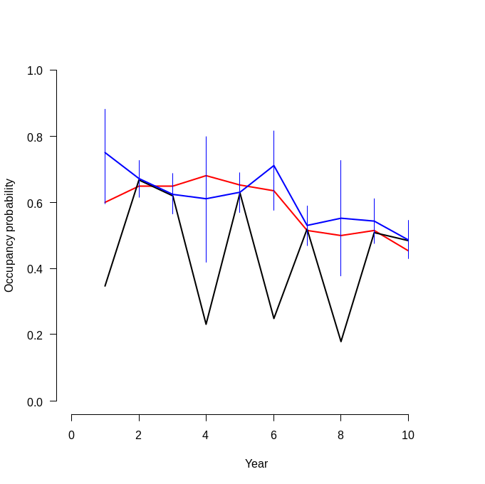
Fig. 11–2: Comparison of the true occupancy probability (red line), the observed occupancy proportion (black line) and the estimate under the dynamic site-occupancy model (blue line, with 95% CRI).

# Call JAGS from R (ART 2.82 min)
library("R2jags")# requires rjags
system.time(out2 <- jags(win.data, inits, params, "Dynocc.txt", n.chains = nc, n.thin = nt, n.iter = ni, n.burnin = nb))

# Summarize posteriors from JAGS
print(ou2, dig = 2)
Inference for Bugs model at "Dynocc.txt", fit using jags,
3 chains, each with 2500 iterations (first 500 discarded), n.thin = 4
n.sims = 1500 iterations saved
mu.vect sd.vect 2.5% 25% 50% 75% 97.5% Rhat n.eff
gamma[1] 0.25 0.15 0.01 0.13 0.25 0.37 0.54 1.01 160
gamma[2] 0.33 0.05 0.23 0.29 0.33 0.36 0.44 1.00 1500
gamma[3] 0.46 0.12 0.25 0.37 0.45 0.53 0.71 1.00 1000
gamma[4] 0.37 0.12 0.08 0.30 0.39 0.46 0.56 1.05 260
gamma[5] 0.39 0.09 0.23 0.34 0.39 0.45 0.57 1.00 1500
gamma[6] 0.14 0.08 0.01 0.08 0.14 0.20 0.31 1.00 730
gamma[7] 0.33 0.10 0.16 0.25 0.31 0.40 0.53 1.02 130
gamma[8] 0.25 0.11 0.03 0.18 0.26 0.33 0.44 1.12 42
gamma[9] 0.23 0.04 0.14 0.19 0.23 0.26 0.32 1.00 1500
growthr[1] 0.89 0.10 0.75 0.83 0.88 0.94 1.15 1.05 61
growthr[2] 0.93 0.05 0.83 0.90 0.93 0.96 1.03 1.00 1500
growthr[3] 0.95 0.17 0.65 0.82 0.94 1.07 1.27 1.00 1200
growthr[4] 1.10 0.20 0.79 0.95 1.07 1.23 1.57 1.00 1100
growthr[5] 1.13 0.10 0.92 1.06 1.13 1.19 1.31 1.01 350
growthr[6] 0.75 0.07 0.63 0.70 0.74 0.79 0.90 1.01 430
growthr[7] 1.06 0.18 0.69 0.94 1.06 1.19 1.40 1.02 110
growthr[8] 1.01 0.20 0.73 0.87 0.97 1.11 1.51 1.02 100
growthr[9] 0.90 0.06 0.78 0.85 0.89 0.93 1.03 1.00 1500
n.occ[1] 190.49 18.40 151.00 179.00 192.00 204.00 222.00 1.04 68
n.occ[2] 168.37 1.25 167.00 167.00 168.00 169.00 171.00 1.00 1500
n.occ[3] 156.29 1.17 155.00 155.00 156.00 157.00 159.00 1.00 1500
n.occ[4] 147.72 24.67 104.00 129.00 146.00 165.00 196.52 1.00 770
n.occ[5] 158.22 1.17 157.00 157.00 158.00 159.00 161.00 1.00 1500
n.occ[6] 178.35 13.62 150.00 169.00 179.00 189.00 201.00 1.00 510
n.occ[7] 132.16 1.64 130.00 131.00 132.00 133.00 136.00 1.00 1500
n.occ[8] 139.99 23.41 92.00 124.00 140.00 157.00 182.00 1.02 110
n.occ[9] 136.41 3.73 130.00 134.00 136.00 139.00 144.00 1.00 440
n.occ[10] 121.66 0.85 121.00 121.00 121.00 122.00 124.00 1.00 1500
p[1] 0.18 0.03 0.14 0.17 0.18 0.20 0.24 1.03 88
p[2] 0.80 0.02 0.76 0.79 0.80 0.81 0.84 1.00 1500
p[3] 0.81 0.02 0.77 0.80 0.81 0.82 0.84 1.00 720
p[4] 0.16 0.03 0.11 0.14 0.16 0.18 0.23 1.00 1500
p[5] 0.81 0.02 0.77 0.79 0.81 0.82 0.84 1.00 1500
p[6] 0.14 0.02 0.11 0.13 0.14 0.15 0.18 1.00 1200
p[7] 0.75 0.02 0.70 0.73 0.75 0.77 0.80 1.00 950
p[8] 0.13 0.03 0.09 0.11 0.13 0.15 0.21 1.01 250
p[9] 0.58 0.03 0.52 0.56 0.58 0.60 0.64 1.00 850
p[10] 0.83 0.02 0.78 0.81 0.83 0.84 0.86 1.00 830
phi[1] 0.80 0.04 0.71 0.77 0.80 0.83 0.87 1.00 1500
phi[2] 0.77 0.03 0.70 0.75 0.77 0.80 0.83 1.00 1500
phi[3] 0.67 0.11 0.46 0.59 0.67 0.75 0.87 1.00 1500
phi[4] 0.80 0.05 0.69 0.76 0.80 0.83 0.89 1.00 510
phi[5] 0.89 0.07 0.76 0.85 0.90 0.95 0.99 1.01 470
phi[6] 0.68 0.05 0.59 0.65 0.69 0.72 0.78 1.00 1500
phi[7] 0.77 0.11 0.52 0.70 0.78 0.85 0.96 1.02 180
phi[8] 0.77 0.06 0.65 0.73 0.77 0.81 0.89 1.00 1300
phi[9] 0.70 0.04 0.62 0.68 0.71 0.73 0.78 1.00 1500
psi[1] 0.76 0.08 0.59 0.71 0.77 0.81 0.89 1.04 69
psi[2] 0.67 0.03 0.61 0.65 0.67 0.69 0.73 1.00 1500
psi[3] 0.63 0.03 0.56 0.60 0.63 0.65 0.69 1.00 1200
psi[4] 0.59 0.10 0.41 0.51 0.59 0.66 0.79 1.00 1500
psi[5] 0.63 0.03 0.57 0.61 0.63 0.65 0.69 1.00 570
psi[6] 0.71 0.06 0.59 0.67 0.71 0.75 0.81 1.00 910
psi[7] 0.53 0.03 0.47 0.51 0.53 0.55 0.59 1.00 980
psi[8] 0.56 0.10 0.36 0.49 0.56 0.63 0.73 1.02 130
psi[9] 0.55 0.03 0.48 0.52 0.54 0.57 0.61 1.01 390
psi[10] 0.49 0.03 0.42 0.47 0.49 0.51 0.55 1.00 460
turnover[1] 0.10 0.08 0.00 0.03 0.08 0.15 0.31 1.02 110
turnover[2] 0.17 0.03 0.12 0.15 0.17 0.19 0.23 1.00 1500
turnover[3] 0.29 0.05 0.18 0.25 0.29 0.32 0.39 1.00 680
turnover[4] 0.26 0.12 0.03 0.17 0.25 0.34 0.48 1.04 320
turnover[5] 0.21 0.04 0.12 0.18 0.20 0.23 0.29 1.00 840
turnover[6] 0.08 0.06 0.00 0.04 0.07 0.11 0.21 1.00 670
turnover[7] 0.27 0.06 0.16 0.23 0.27 0.31 0.38 1.01 220
turnover[8] 0.22 0.12 0.02 0.13 0.21 0.29 0.48 1.10 46
turnover[9] 0.21 0.04 0.13 0.18 0.21 0.24 0.30 1.00 1500
deviance 4432.41 54.01 4324.98 4397.45 4432.35 4469.85 4541.04 1.01 360

For each parameter, n.eff is a crude measure of effective sample size,
and Rhat is the potential scale reduction factor (at convergence, Rhat=1).

DIC info (using the rule, pD = var(deviance)/2)
pD = 1452.2 and DIC = 5884.6
DIC is an estimate of expected predictive error (lower deviance is better).

Next, we want to compare the classical and the Bayesian estimates of some quantities. We need to compute the estimates on the probability scale in unmarked, where naturally, all estimates are on the link scale (the logit). Back-transforming estimates when covariates such as year are present involves an extra step. Specifically, we need to tell unmarked the values of our covariate at which we want an estimate. This can be done using backTransform() in combination with linearComb(), although it can be easier to use predict(). predict() allows the user to supply a data.frame in which each row represents a combination of covariate values of interest. Below, we create data.frames called nd with each row representing a year. Then we request yearly estimates of the probability of extinction, colonization and detection, and compare them to "truth", i.e., the values with which we simulated the data set. Note that there are K-1 extinction and colonization
parameters in this case, so we do not need to include year `10' in nd.
We will cheat a little bit and predict for the fully time-dependent model, even though it did not come out first in the AIC model comparison earlier.

nd <- data.frame(year=c('01','02','03','04','05','06','07','08','09'))
E.ext <- predict(fm8, type='ext', newdata=nd)
E.col <- predict(fm8, type='col', newdata=nd)
nd <- data.frame(year=c('01','02','03','04','05','06','07','08','09','10'))
E.det <- predict(fm8, type='det', newdata=nd)

predict() returns the predictions along with standard errors and confidence intervals. These can be used to create plots. The with() function is used to simplify the process of requesting the columns of data.frame returned by predict(). Then, we plot the true values, the estimates from unmarked and those from WinBUGS in the same plot.

op <- par(mfrow=c(3,1), mai=c(0.6, 0.6, 0.1, 0.1))
with(E.ext, { # Plot for extinction probability
plot(1:9, Predicted, pch=1, xaxt='n', xlab='Year',
ylab=expression(paste('Extinction probability ( ', epsilon, ' )')),
ylim=c(0,1), col="green")
axis(1, at=1:9, labels=nd$year[1:9])
arrows(1:9, lower, 1:9, upper, code=3, angle=90, length=0.03, col="green")
points((1:9)-0.1, 1-data$phi, col="red", lwd = 1, pch=16)
points((1:9)+0.1, 1-out$summary[11:19,1], col="blue", lwd = 1, pch=16)
segments(((1:9)+0.1), (1-out1$summary[11:19,3]), ((1:9)+0.1), (1-out1$summary[11:19,7]), col = "blue", lwd = 1)
legend(7, 1, c('Truth', 'ML', 'Posterior mean'), col=c("red", "green", "blue"), pch=c(16, 1),
cex=0.8)
})

with(E.col, { # Plot for colonization probability
plot(1:9, Predicted, pch=1, xaxt='n', xlab='Year',
ylab=expression(paste('Colonization probability ( ', gamma, ' )')),
ylim=c(0,1), col="green")
axis(1, at=1:9, labels=nd$year[1:9])
arrows(1:9, lower, 1:9, upper, code=3, angle=90, length=0.03, col="green")
points((1:9)-0.1, data$gamma, col="red", lwd = 1, pch=16)
points((1:9)+0.1, out1$summary[20:28,1], col="blue", lwd = 1, pch=16)
segments(((1:9)+0.1), out1$summary[20:28,3], ((1:9)+0.1), out1$summary[20:28,7], col = "blue", lwd = 1)
legend(7, 1, c('Truth', 'ML', 'Posterior mean'), col=c("red", "green", "blue"), pch=c(16, 1),
cex=0.8)
})

with(E.det, { # Plot for detection probability: note 10 years
plot(1:10, Predicted, pch=1, xaxt='n', xlab='Year',
ylab=expression(paste('Detection probability ( ', p, ' )')),
ylim=c(0,1), col="green")
axis(1, at=1:10, labels=nd$year[1:10])
arrows(1:10, lower, 1:10, upper, code=3, angle=90, length=0.03, col="green")
points((1:10)-0.1, data$p, col="red", lwd = 1, pch=16)
points((1:10)+0.1, out1$summary[29:38,1], col="blue", lwd = 1, pch=16)
segments(((1:10)+0.1), out1$summary[29:38,3], ((1:10)+0.1), out1$summary[29:38,7], col = "blue", lwd = 1)
legend(8, 1, c('Truth', 'ML', 'Posterior mean'), col=c("red", "green", "blue"), pch=c(16, 1),
cex=0.8)
})
par(op)

The resulting figure shows that both maximum likelihood and Bayesian estimates are numerically very similar and moreover that their 95% uncertainty intervals (usually) include the true parameter values.

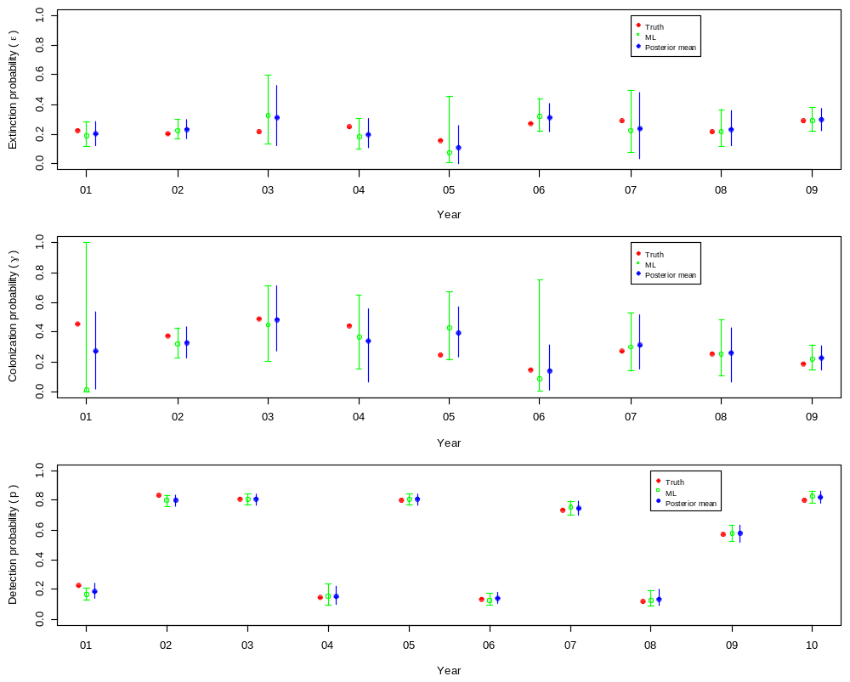
Fig. 11–3: Comparison of the true with the estimated probabilities of extinction, colonization and detection with the MLEs from unmarked and the Bayesian estimates from WinBUGS. Uncertainty intercals are 95% CIs and CRIs, respectively.

Estimates of occupancy probability in years K > 1 must be derived from the estimates of first-year occupancy and the two parameters governing the dynamics, extinction/survival and colonization. unmarked does this automatically in two ways. First, the population-level estimates of occupancy probability 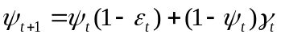are calculated and stored in the slot named projected. Slots can be accessed using the @ operator, e.g. fm@projected. In some cases, interest may lie in making inference about the proportion of the sampled sites that are occupied, rather than the entire population of sites. These estimates are contained in the smoothed slot of the fitted model. Thus, the projected values are estimates of population parameters, and the smoothed estimates are of the finite-sample quantities. Discussion of the differences can be found in Weir et al. (2009).

The next table compares Truth for occupancy with the estimates from unmarked and WinBUGS. Standard errors for the ML estimates could be obtained using the bootstrap (see the colext vignette for how to do this).

cbind(psi=psi, ML.estimates=projected(fm)[2,], Bayesian.estimates=out$summary[1:10, c(1:3,7)])

11.4. Mapping crossbill range dynamics in Switzerland using unmarked and BUGS/JAGS
We have emphasized throughout the book that any model of abundance or related population quantities that contains spatially-indexed covariates essentially represents a model of species distribution or abundance. In particular, if the values of all spatial covariates in the model are known over some larger area, predictions of the population quantity can be obtained for this entire area and maps can be drawn. Next, we illustrate this will all components of the dynamic occupancy model applied to detection/nondetection data of the European crossbill (see Fig. 8-6) for the years 1999–2007 to produce Swiss maps of the probabilities of occupancy, extinction, colonization and detection. We keep to the usual work flow of our analyses of hierarchical models using unmarked.

### Step 1: Load data, do data manipulations and create unmarked data frame
# Load package unmarked
library(unmarked)

# Read in data set
crossbill <- read.table("crossbill.txt", header=TRUE)
str(crossbill)

> str(crossbill)
'data.frame': 267 obs. of 58 variables:
$ id : int 1 2 3 4 5 6 7 8 9 10 ...
$ ele : int 450 450 1050 950 1150 550 750 650 550 550 ...
$ forest : int 3 21 32 9 35 2 6 60 5 13 ...
$ surveys: int 3 3 3 3 3 3 3 3 3 3 ...
$ det991 : int 0 0 NA 0 0 NA 0 0 0 0 ...
$ det992 : int 0 0 NA 0 0 NA 0 0 0 0 ...
$ det993 : int 0 0 NA 0 0 NA 0 0 0 0 ...
[ ... ]
$ det071 : int 0 0 0 0 1 0 0 0 0 0 ...
$ det072 : int 0 0 1 1 1 0 0 1 0 0 ...
$ det073 : int 0 0 0 1 1 0 0 1 0 0 ...
$ date991: int 34 17 NA 29 24 NA 26 23 21 37 ...
$ date992: int 59 33 NA 59 45 NA 54 43 36 62 ...
$ date993: int 65 65 NA 65 65 NA 74 71 56 75 ...
[ ... ]
$ date071: int 20 19 22 22 15 21 21 37 29 20 ...
$ date072: int 46 50 55 49 43 40 53 50 43 40 ...
$ date073: int 54 56 61 70 60 49 64 65 57 60 ...

# Do some data manipulations
# Extract response and survey dates and mean-impute dates
y.cross <- as.matrix(crossbill[,5:31])
DATE <- as.matrix(crossbill[,32:58])
sum(is.na(y.cross)) # Check how many NA's
sum(is.na(DATE)) # Check how many NA's
cmeans.date <- apply(DATE, 2, mean, na.rm = TRUE)
for(j in 1:27){
DATE[,j][is.na(DATE[,j])] <- cmeans.date[j]
}
sum(is.na(DATE)) # Check how many NA's now

# Create same NA structure for response and date
DATE[is.na(y.cross)] <- NA
sum(is.na(y.cross)) # Check how many NA's
sum(is.na(DATE)) # Check how many NA's

# Standardize covariates for elevation, forest and survey date
mean.ele <- mean(crossbill$ele, na.rm=TRUE)
sd.ele <- sd(crossbill$ele, na.rm=TRUE)
elev <- (crossbill$ele - mean.ele) / sd.ele
mean.forest <- mean(crossbill$forest, na.rm=TRUE)
sd.forest <- sd(crossbill$forest, na.rm=TRUE)
forest <- (crossbill$forest - mean.forest) / sd.forest
mean.date <- mean(DATE, na.rm=TRUE)
sd.date <- sd(c(DATE), na.rm=TRUE)
DATE <- (DATE - mean.date) / sd.date

cat(" *** Values used for standardization of covariates ***\n
mean(elevation):", mean.ele,
"\n sd(elevation): ", sd.ele,
"\n mean(forest): ", mean.forest,
"\n sd(forest): ", sd.forest,
"\n mean(date): ", mean.date,
"\n sd(date): ", sd.date, "\n\n")

# Generate year covariate
year <- as.character(1999:2007)
year <- matrix(year, nrow(crossbill), 9, byrow=TRUE)

# Generate unmarked data frame
umf <- unmarkedMultFrame(y=crossbill[,5:31],
siteCovs=data.frame(elev, forest), yearlySiteCovs=list(year=year),
obsCovs=list(date=DATE),
numPrimary=9)
summary(umf)
> summary(umf)
unmarkedFrame Object

267 sites
Maximum number of observations per site: 27
Mean number of observations per site: 24.99
Number of primary survey periods: 9
Number of secondary survey periods: 3
Sites with at least one detection: 165

Tabulation of y observations:
0 1 <NA>
5311 1362 536

Site-level covariates:
elev forest
Min. :-1.466e+00 Min. :-1.256e+00
1st Qu.:-9.978e-01 1st Qu.:-9.484e-01
Median :-6.138e-02 Median :-6.307e-02
Mean :-4.043e-17 Mean :-6.686e-18
3rd Qu.: 1.031e+00 3rd Qu.: 7.861e-01
Max. : 2.436e+00 Max. : 2.322e+00

Observation-level covariates:
date
Min. :-2.016e+00
1st Qu.:-7.890e-01
Median : 2.883e-02
Mean :-7.162e-17
3rd Qu.: 7.558e-01
Max. : 2.891e+00
NA's : 5.360e+02

Yearly-site-level covariates:
year
1999 :267
2000 :267
2001 :267
2002 :267
2003 :267
2004 :267
(Other):801
# Note three types of covariates possible in this kind of data set

### Step 2: Fit a series of models (very abbreviated version of Kéry et al. 2013) and do model selection

# Function colext fits dynamic site-occupancy model of MacKenzie et al. (2003)
# See ?colext and vignette("colext")

### Two Null models, a fully constant one and the fully time-dependent model
# A Null model with constant params throughout
system.time(
(fm0 <- colext(psiformula= ~ 1, gammaformula = ~ 1, epsilonformula = ~ 1, pformula = ~ 1, umf))
)
summary(fm0)
fm0@negLogLike

# Fully time-dependent model
system.time(
(fm1 <- colext(~ 1, ~ year-1, ~year-1, ~year-1, umf))
)
summary(fm1)
fm1@negLogLike

### Select between time constancy and time-dependence
models <- fitList(
'psi(.)gam(.)eps(.)p(.)' = fm0,
'psi(.)gam(Y)eps(Y)p(Y)' = fm1)
(ms <- modSel(models))

Next, we only show the latest two steps of a long process of covariate modeling. We also illustrate how the estimates from a neighbouring model can be used as starting values for the numerical optimisation of the likelihood function of a model. Choosing good starting values in a ML analysis can be decisive, because otherwise sometimes no convergence is achieved or, worse yet, the software “converges” to a local optimum or gets otherwise stuck at a place of the multidimensional likelihood surface, which does not represent the MLE.
Note also how we can choose not to compute the SEs (this is the argument se = FALSE), which greatly reduces the run time. For model selection we don’t need SEs.

system.time( # ART 145.35 sec
(fm23 <- colext(~ elev + I(elev^2) + forest + I(forest^2) + elev:forest + elev:I(forest^2) + I(elev^2):forest + I(elev^2):I(forest^2),
~ (year-1) + elev + I(elev^2) + forest + I(forest^2) + elev:forest + elev:I(forest^2) + I(elev^2):forest + I(elev^2):I(forest^2),
~ (year-1) + elev + I(elev^2),
~ (year-1) + elev + I(elev^2) + forest + I(forest^2) + elev:forest + elev:I(forest^2)+ I(elev^2):forest + I(elev^2):I(forest^2) + date+I(date^2), umf, control=list(trace=TRUE, REPORT=1, maxit = 500), se = FALSE))
)
summary(fm23)
length(coef(fm23))
fm23@negLogLike

# Create vector with inits for model 24. Has to be same length
# as the parameter vector of model 24, so pad up with zeroes.
inits <- c(coef(fm23)[1:27], 0, coef(fm23)[28:54])
system.time( # ART 746.90 sec
(fm24 <- colext(~ elev + I(elev^2) + forest + I(forest^2) + elev:forest + elev:I(forest^2) + I(elev^2):forest + I(elev^2):I(forest^2),
~ (year-1) + elev + I(elev^2) + forest + I(forest^2) + elev:forest + elev:I(forest^2) + I(elev^2):forest + I(elev^2):I(forest^2),
~ (year-1) + elev + I(elev^2) + forest,
~ (year-1) + elev + I(elev^2) + forest + I(forest^2) + elev:forest + elev:I(forest^2) + I(elev^2):forest + I(elev^2):I(forest^2) + date + I(date^2), umf, starts = inits, control=list(trace=TRUE, REPORT=1, maxit = 500), se = TRUE))
)

summary(fm24)
Call:
colext(psiformula = ~elev + I(elev^2) + forest + I(forest^2) +
elev:forest + elev:I(forest^2) + I(elev^2):forest + I(elev^2):I(forest^2),
gammaformula = ~(year - 1) + elev + I(elev^2) + forest +
I(forest^2) + elev:forest + elev:I(forest^2) + I(elev^2):forest +
I(elev^2):I(forest^2), epsilonformula = ~(year - 1) +
elev + I(elev^2) + forest, pformula = ~(year - 1) + elev +
I(elev^2) + forest + I(forest^2) + elev:forest + elev:I(forest^2) +
I(elev^2):forest + I(elev^2):I(forest^2) + date + I(date^2),
data = umf, starts = inits, se = TRUE, control = list(trace = TRUE,
REPORT = 1, maxit = 500))

Initial (logit-scale):
Estimate SE z P(>|z|)
(Intercept) 15.78 5.94 2.66 0.00791
elev 9.94 3.60 2.76 0.00571
I(elev^2) -13.39 5.12 -2.62 0.00892
forest -23.65 8.21 -2.88 0.00396
I(forest^2) 7.93 2.73 2.91 0.00365
elev:forest -9.93 4.49 -2.21 0.02708
elev:I(forest^2) 2.93 1.91 1.54 0.12426
I(elev^2):forest 13.49 5.01 2.69 0.00709
I(elev^2):I(forest^2) -1.84 1.36 -1.36 0.17393

Colonization (logit-scale):
Estimate SE z P(>|z|)
year1999 0.2565 0.448 0.5720 5.67e-01
year2000 -0.3698 0.383 -0.9652 3.34e-01
year2001 0.5991 0.351 1.7078 8.77e-02
year2002 0.2426 0.366 0.6631 5.07e-01
year2003 -0.7559 0.507 -1.4898 1.36e-01
year2004 -0.6400 0.432 -1.4806 1.39e-01
year2005 -0.0414 0.451 -0.0916 9.27e-01
year2006 -0.5227 0.574 -0.9103 3.63e-01
elev 0.5548 0.223 2.4884 1.28e-02
I(elev^2) -0.9679 0.308 -3.1472 1.65e-03
forest -0.9876 0.339 -2.9133 3.58e-03
I(forest^2) 0.1699 0.260 0.6545 5.13e-01
elev:forest 0.3814 0.265 1.4381 1.50e-01
elev:I(forest^2) 0.0276 0.267 0.1032 9.18e-01
I(elev^2):forest 1.5790 0.404 3.9127 9.13e-05
I(elev^2):I(forest^2) -0.7728 0.381 -2.0301 4.23e-02

Extinction (logit-scale):
Estimate SE z P(>|z|)
year1999 -0.0717 0.270 -0.266 7.91e-01
year2000 0.7468 0.352 2.119 3.41e-02
year2001 -0.2535 0.396 -0.641 5.22e-01
year2002 -1.6612 0.497 -3.343 8.29e-04
year2003 -1.0433 0.421 -2.476 1.33e-02
year2004 -0.8247 0.362 -2.277 2.28e-02
year2005 -0.9686 0.623 -1.556 1.20e-01
year2006 -1.2984 0.485 -2.679 7.39e-03
elev -0.9621 0.220 -4.367 1.26e-05
I(elev^2) -0.2342 0.234 -1.001 3.17e-01
forest -0.7698 0.152 -5.058 4.24e-07

Detection (logit-scale):
Estimate SE z P(>|z|)
year1999 -1.3511 0.1577 -8.5700 1.03e-17
year2000 0.2950 0.1732 1.7030 8.86e-02
year2001 -0.3730 0.2071 -1.8010 7.17e-02
year2002 -0.1744 0.1804 -0.9667 3.34e-01
year2003 0.1329 0.1585 0.8385 4.02e-01
year2004 -0.2309 0.1789 -1.2911 1.97e-01
year2005 0.4160 0.1777 2.3412 1.92e-02
year2006 -0.8731 0.2149 -4.0626 4.85e-05
year2007 0.0757 0.1666 0.4541 6.50e-01
elev 0.5341 0.1201 4.4478 8.67e-06
I(elev^2) -0.0131 0.1335 -0.0982 9.22e-01
forest 0.1593 0.1538 1.0352 3.01e-01
I(forest^2) -0.0390 0.0858 -0.4547 6.49e-01
date 0.0578 0.0531 1.0899 2.76e-01
I(date^2) 0.1044 0.0441 2.3663 1.80e-02
elev:forest 0.2717 0.1662 1.6348 1.02e-01
elev:I(forest^2) -0.0287 0.1027 -0.2793 7.80e-01
I(elev^2):forest 0.6870 0.1880 3.6532 2.59e-04
I(elev^2):I(forest^2) -0.2842 0.1222 -2.3264 2.00e-02

AIC: 4618.695
Number of sites: 267
optim convergence code: 0
optim iterations: 325
Bootstrap iterations: 0

# May keep an aye on negLogLike to check for local optima
fm24@negLogLike

# Compare models
models <- fitList(
'psi(.)gam(.)eps(.)p(.)' = fm0,
'psi(.)gam(Y)eps(Y)p(Y)' = fm1,
'Slightly fewer covariates' = fm23,
'LOTS of covariates' = fm24)
(ms <- modSel(models))
> (ms <- modSel(models))
Hessian is singular.
nPars AIC delta AICwt cumltvWt
LOTS of covariates 55 4618.69 0.00 1.0e+00 1.00
Slightly fewer covariates 54 4648.66 29.97 3.1e-07 1.00
psi(.)gam(Y)eps(Y)p(Y) 26 5131.34 512.64 4.8e-112 1.00
psi(.)gam(.)eps(.)p(.) 4 5197.44 578.75 2.1e-126 1.00

### Step 3: Analyse results: Goodness of fit and predictions

# Check goodness of fit (not run)
# Define function to compute chisquare statistic
chisq <- function(fm) {
umf <- getData(fm)
y <- getY(umf)
sr <- fm@sitesRemoved
if(length(sr)>0)
y <- y[-sr,,drop=FALSE]
fv <- fitted(fm, na.rm=TRUE)
y[is.na(fv)] <- NA
#sum((y-fv)^2/(fv*(1-fv)))
sum((y-fv)^2/(fv*(1-fv)), na.rm=TRUE)
}

# Produce large parametric bootstrap sample for the model
system.time(pb.gof <- parboot(fm24, statistic=chisq, report = 1, nsim = 100))
# Model fitted, so go on with producing predictions

# Extract estimates into other object
tmp <- summary(fm24)

### Predict on a regular grid of n-by-n using values of prediction covariates (ep, fp, dp, see above)
# Let elevation only go till 2250

n.prediction.points <- 250 # Don't choose too high !!!
ep.original <- seq(from=min(crossbill$ele), to = 2250, length.out = n.prediction.points)
ep <- (ep.original-mean.ele)/sd.ele
fp.original <- seq(from = min(crossbill$forest), to = max(crossbill$forest), length.out = n.prediction.points)
fp <- (fp.original-mean.forest)/sd.forest
dates <- as.matrix(crossbill[,32:58])
first.survey <- min(as.numeric(dates), na.rm = TRUE)
last.survey <- max(as.numeric(dates), na.rm = TRUE)
dp.original <- seq(from = first.survey, to = last.survey, length.out = n.prediction.points)
dp <- (dp.original-mean.date)/sd.date

### Predict 2D for detection probability
########################################
(detpar <- tmp$det[,1])
names(detpar) <- rownames(tmp$det)

# Get daily predictions of detection probability for each year
pred.matrix <- array(NA, dim = c(length(dp.original), 9))
for(i in 1:9){
pred.matrix[,i] <- plogis(
detpar[i] + detpar["date"]*dp + detpar["I(date^2)"]*dp^2)
}
mean.p <- apply(pred.matrix, 1, mean)
plot(dp.original, mean.p, type = "l", lwd = 3, col = "blue", ylim = c(0,1), las = 1, xlab = "Date (1 = April 1)", ylab = "Expected detection probability", cex.lab = 1.2)
for(i in 1:9){
lines(dp.original, pred.matrix[,i], col = "grey", lwd = 3)
}
lines(dp.original, mean.p, col = "blue", lwd = 3)

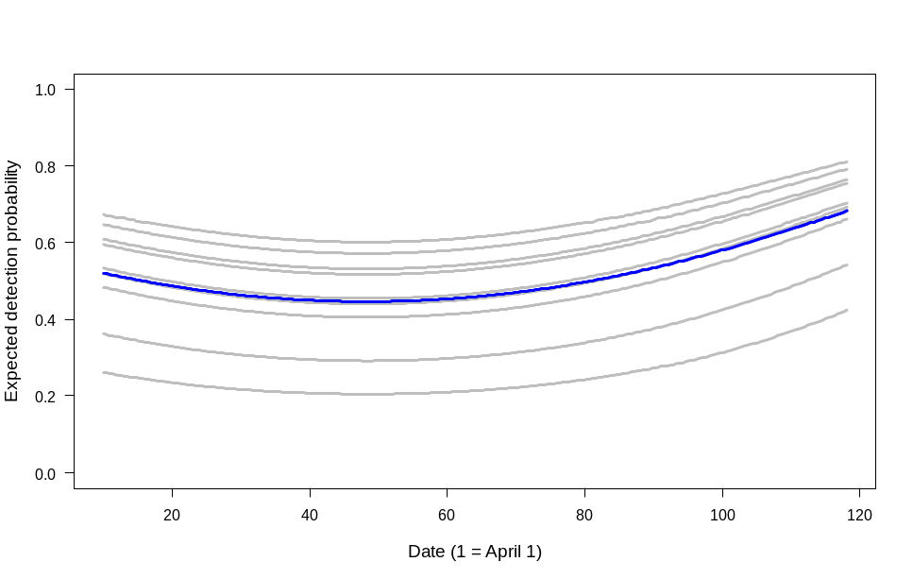
Fig. 11–4: Expected detection probability of Swiss crossbills in 1 km² sampling quadrats for over the season and for each year 1999–2007. Blue line is the average over all 9 years.

### Predict 3D for first-year occupancy
#######################################

(psipar <- tmp$psi[,1])
names(psipar) <- rownames(tmp$psi)
pred.matrix <- array(NA, dim = c(n.prediction.points, n.prediction.points))

# Get predictions on a matrix for elevation and forest cover
for(i in 1:n.prediction.points){
pred.matrix[,i] <- plogis(
psipar[1] + psipar["elev"]*ep + psipar["I(elev^2)"]*ep^2 + psipar["forest"]*fp[i] + psipar["I(forest^2)"]*fp[i]^2+
psipar["elev:forest"]*ep*fp[i] + psipar["elev:I(forest^2)"]*ep*fp[i]^2 + psipar["I(elev^2):forest"]*ep^2*fp[i] + psipar["I(elev^2):I(forest^2)"]*ep^2*fp[i]^2)
}

# Using image()
image(x=ep.original, y=fp.original, z=pred.matrix, col = topo.colors(10), axes = FALSE, xlab = "Elevation [m]", ylab = "Forest cover [%]",
cex.lab = 1.2)
contour(x=ep.original, y=fp.original, z=pred.matrix, add = TRUE, col = "black")
axis(1, at = seq(min(ep.original), max(ep.original), by = 250))
axis(2, at = seq(0, 100, by = 10))
box()
title(main = "First-year occupancy probability", font.main = 4)

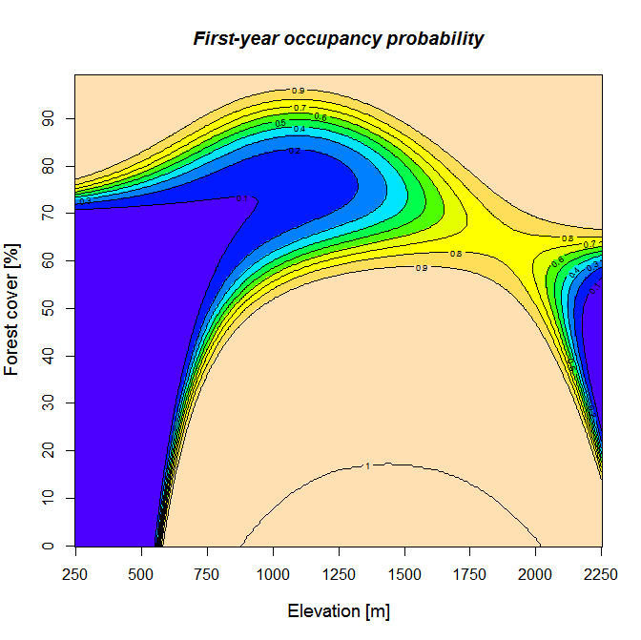
Fig. 11–5: Two-dimensional predictions of a parameter (first-year occupancy) along a gradient of forest cover and elevation.

library(sp)

# Import landscape data: PLEASE DO NOT DISTRIBUTE THESE DATA
###########################################################
ldat <- read.table("CH.txt", header = TRUE, sep = "\t")

# Standardize using same values as for original data set in model fitting
EP <- (ldat$median.elevation - mean.ele) / sd.ele
FP <- (ldat$forest - mean.forest) / sd.forest

# Compute predicted occupancy probability
pred.occ <- plogis(psipar[1] + psipar["elev"]*EP + psipar["I(elev^2)"]*EP^2 + psipar["forest"]*FP + psipar["I(forest^2)"]*FP^2+
psipar["elev:forest"]*EP*FP + psipar["elev:I(forest^2)"]*EP*FP^2 + psipar["I(elev^2):forest"]*EP^2*FP + psipar["I(elev^2):I(forest^2)"]*EP^2*FP^2)

# Prepare Swiss coordinates and produce map
coordCH <- matrix(cbind(ldat$coordx + 0.5, ldat$coordy + 0.5), ncol = 2)

# Rescale coordinates from km to m
xcor <- coordCH[,1] * 1000
ycor <- coordCH[,2] * 1000

# Define a new dataframe with coordinates and outcome to be plotted
OCC <- data.frame(x = xcor, y = ycor, elev = pred.occ)

# Convert the dataframe first into a SpatialPointsDataFrame and then into a SpatialPixelsDataFrame
coordinates(OCC)<- ~x+y
gridded(OCC) <- TRUE

# Plot the map using custom color palette
mapPalette <- colorRampPalette(c("lightyellow", "yellow", "orange", "red", "darkred"))
# mapPalette <- colorRampPalette(c("yellow", "orange", "red", "darkred"))
spplot(OCC, col.regions = mapPalette(100))

# Plot the map using custom color palette
# mapPalette <- colorRampPalette(c("grey", "lightgreen", "darkgreen"))
mapPalette <- colorRampPalette(c("grey", "yellow", "orange", "red"))
spplot(OCC, col.regions = mapPalette(100))

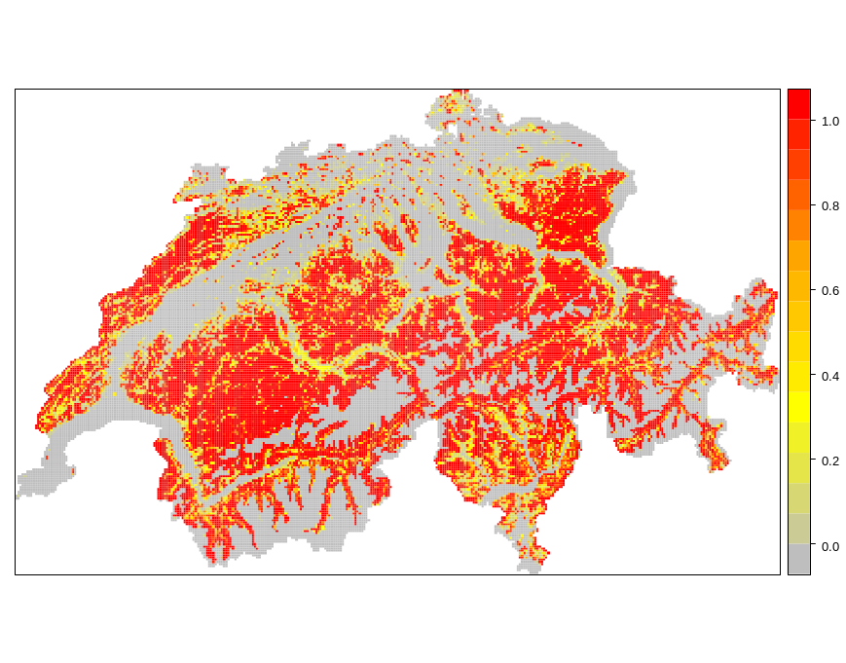
Fig. 11–6: Two-dimensional predictions of a parameter (first-year occupancy -- 1999) on the Swiss landscape.
This is thus a simple species-distribution model for the the first year of survey. However, we can do much better still: we can project all the other parameters also ! We will define a function that will produce maps for ALL parameters and for ALL years.

# Function to produce maps
# --------- Start of function definition -----------------
all.map.fn <- function(nyears = 9, tmp = summary(fm24)){

# This function maps the relationships between all parameters of
# the dynamic occupancy model and elevation and forest cover onto
# a map of Switzerland.
# Written by Marc Kery & Jérôme Guélat, 21 September 2011

require(sp)
require(raster)

# Import landscape data: HIGHLY CONFIDENTIAL, DO NOT HAND OUT
ldat <- read.table("CH.txt", header = TRUE, sep = "\t")
nsites <- nrow(ldat)

# Standardize using same values as for original data set in model fitting
EP <- (ldat$median.elevation - mean.ele) / sd.ele
FP <- (ldat$forest - mean.forest) / sd.forest

# Extract parameter estimates for each parameter type
psipar <- tmp$psi[,1]
names(psipar) <- rownames(tmp$psi)
colpar <- tmp$col[,1]
names(colpar) <- rownames(tmp$col)
extpar <- tmp$ext[,1]
names(extpar) <- rownames(tmp$ext)
detpar <- tmp$det[,1]
names(detpar) <- rownames(tmp$det)

# Create arrays to contain predictions for each km2 in Switzerland
pred.occ1 <- numeric(nsites) # First-year occupancy
pred.col <- pred.ext <- matrix(NA, nrow = nsites, ncol = (nyears-1)) # Colonization and extinction prob.
pred.occ <- pred.det <- matrix(NA, nrow = nsites, ncol = nyears) # Occupancy and detection prob. for all years

# Compute predicted first-year occupancy probability
pred.occ1 <- plogis(psipar[1] + psipar["elev"]*EP + psipar["I(elev^2)"]*EP^2 + psipar["forest"]*FP + psipar["I(forest^2)"]*FP^2 + psipar["elev:forest"]*EP*FP + psipar["elev:I(forest^2)"]*EP*FP^2 + psipar["I(elev^2):forest"]*EP^2*FP + psipar["I(elev^2):I(forest^2)"]*EP^2*FP^2)
pred.occ[,1] <- pred.occ1

# Compute predicted colonization and extinction probability
for(j in 1:(nyears-1)){
pred.col[,j] <- plogis(colpar[j] + colpar["elev"]*EP + colpar["I(elev^2)"]*EP^2 + colpar["forest"]*FP + colpar["I(forest^2)"]*FP^2 + colpar["elev:forest"]*EP*FP + colpar["elev:I(forest^2)"]*EP*FP^2 + colpar["I(elev^2):forest"]*EP^2*FP + colpar["I(elev^2):I(forest^2)"]*EP^2*FP^2)
pred.ext[,j] <- plogis(extpar[j] + extpar["elev"]*EP + extpar["I(elev^2)"]*EP^2 + extpar["forest"]*FP)
pred.occ[,(j+1)] <- pred.occ[,j] * (1-pred.ext[,j]) + (1-pred.occ[,j]) * pred.col[,j]
}

# Compute predicted detection probability
for(j in 1:nyears){
pred.det[,j] <- plogis(detpar[j] + detpar["elev"]*EP + detpar["I(elev^2)"]*EP^2 + detpar["forest"]*FP + detpar["I(forest^2)"]*FP^2 + detpar["elev:forest"]*EP*FP + detpar["elev:I(forest^2)"]*EP*FP^2 + detpar["I(elev^2):forest"]*EP^2*FP + detpar["I(elev^2):I(forest^2)"]*EP^2*FP^2)
}

# Unite all predictions in a single matrix with named columns
all.pred <- cbind(pred.occ, pred.col, pred.ext, pred.det)
colnames(all.pred) <- c("Occupancy 1999", "Occupancy 2000", "Occupancy 2001", "Occupancy 2002", "Occupancy 2003", "Occupancy 2004", "Occupancy 2005", "Occupancy 2006", "Occupancy 2007",
"Colonization 1999-2000", "Colonization 2000-2001", "Colonization 2001-2002", "Colonization 2002-2003", "Colonization 2003-2004", "Colonization 2004-2005", "Colonization 2005-2006", "Colonization 2006-2007",
"Extinction 1999-2000", "Extinction 2000-2001", "Extinction 2001-2002", "Extinction 2002-2003", "Extinction 2003-2004", "Extinction 2004-2005", "Extinction 2005-2006", "Extinction 2006-2007",
"Detection 1999", "Detection 2000", "Detection 2001", "Detection 2002", "Detection 2003", "Detection 2004", "Detection 2005", "Detection 2006", "Detection 2007")

# Get annual average probabilities
annual.average <- apply(all.pred, 2, mean)

# Prepare Swiss coordinates and produce map
coordCH <- cbind(ldat$coordx + 0.5, ldat$coordy + 0.5)

# Rescale coordinates from km to m
xcor <- coordCH[,1] * 1000
ycor <- coordCH[,2] * 1000

# Now plot all parametters
nparam <- ncol(all.pred)
for(i in 1:nparam) {

# Select column in prediction array
sel.param <- all.pred[,i]
param.name <- colnames(all.pred)[i]
cat("*** Map for:", param.name, " ***\n")

# Define a new dataframe with coordinates and outcome to be plotted
PARAM <- data.frame(x = xcor, y = ycor, z = sel.param)

# Convert the dataframe first into a SpatialPointsDataFrame and then into a SpatialPixelsDataFrame
coordinates(PARAM)<- ~x+y
gridded(PARAM) <- TRUE
# Convert the SpatialPixelsDataFrame into a Raster object
r <- raster(PARAM)

# Plot the map using custom color palette
#mapPalette <- colorRampPalette(c("grey", "lightgreen", "darkgreen"))
mapPalette <- colorRampPalette(c("grey", "yellow", "orange", "red"))
plot(r, col = mapPalette(100), axes = FALSE, box = FALSE)
browser()

}

return(list(annual.average = annual.average))
}
# --------- End of function definition -----------------

### Execute function and rest in awe
all.map.fn(nyears = 9, tmp = summary(fm24))

11.5. Analysis of territory occupancy of Swiss long-eared owls with BUGS/JAGS
Add function of latent variable in one part of the model a covariate in another.
Illustrates one of two great practical advantages of a Bayesian analysis with MCMC: ease of getting derived quantities with full propagation of all uncertainty and ease with which latent variables can be estimates or included in computations.
-> perhaps see next edition of workshop.

11.5. Occupancy analysis of large data sets of opportunistic citizen-science records in “vertical format”.
One of the advantages of an analysis coded in WinBUGS is that it is perhaps easier to choose one’s own data format, that is, one that is particularly adequate for something. Here is an example, in the context of an interesting application of occupancy models.
Ornithological and other centers that collect biological records have always been challenged by temporal changes in sampling effort. Usually, sampling effort is not quantified in citizen-science records and hence, an increase in the number of recorded presences of a species could mean that the species is increasing in abundance or extending its range, or that more people are looking harder for the species, or anything in between. With the advent of internet-based webinterfaces for biological records center, the number of records submitted often increases greatly. Thus, by this increase in observer activity alone, many species appear to increase, even though their populations are known to be stable or appear stable even though their populations are declining. Of course, it is entirely possible for a population to appear to increase, whereas in fact it is declining, if only the observer effort increases strongly enough. With some colleagues, we applied dynamic occupancy models to measure the end result of all observer effort, namely detection probability and the number of surveys (Kéry et al., Cons. Biol., 2009). We derived detection histories and applied dynamic occupancy models. If the observer effort is increasing over time, then this will be reflected in more surveys and possibly increased detection probability. Both components of the overall chance for an occupied site to be detected are accommodated in an occupancy model. We applied this modeling framework for a couple of species to opportunistic data collected in the Swiss Ornithological Institute.
One challenge in this analysis is that there are usually much more than 90% empty cells in the detection history matrix. With some species with very large matrices, unmarked would just collapse. So we analysed these data in WinBUGS and formatted them not in the usual rectangular data matrix, but rather as a single long string of numbers (i.e., a vector). Here we illustrate this and show how we can flexibly re-write the model in WinBUGS for such data in the “long” format. We will analyse citizen science data of the rare middle-spotted woodpecker (Fig. 11–7).

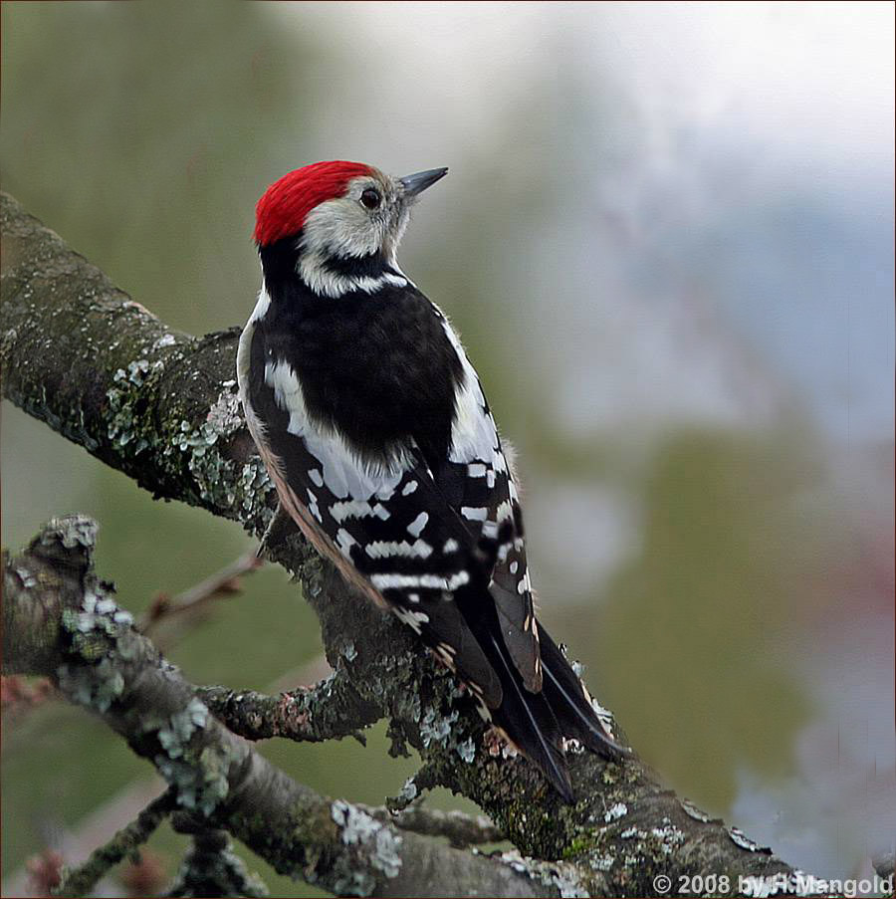
Fig. 11–7: Middle-spotted woodpecker (Dendrocopos medius; borrowed from the web).

We will code this analysis in three steps, represented by three functions, which we will first throw into an R workspace to have them defined in R. Then, we execute one after the other to conduct the analysis. Middle-spotted woodpecker observations count as indicative of a potential breeding pair from Julian day 61 to day 180.
One special feature of this analysis is that we will fit random annual effects for colonisation, survival and detection. This is a typical application of random effects and model that cannot be fitted in unmarked.

# Define function to read and prepare data of a selected species
# ----------- Start of function definition ---------------
data.fn <- function(data.file = "Swiss.middle.spotted.txt"){

iddata <- read.table(data.file, header =T)
str(iddata)

# Determine average survey data for standardisation of date
min.day <- 61
max.day <- 180
mean.day <- mean(c(min.day, max.day))

# Create unique single coordinate
iddata$coord <- as.numeric(paste(iddata$coordx, iddata$coordy, sep = "."))
names(iddata)

# Get number of sites and years
nsite <- max(as.numeric(factor(iddata$coord)))
nyear <- max(as.numeric(factor(iddata$year)))

# Separate detection/nondetection data and data on julian day
(width.detection.matrix <- (dim(iddata)[2] - 5 ) / 2)
DETECTIONS <- as.matrix(iddata[,(5+1):(5+width.detection.matrix)])
DATES <- as.matrix(iddata[,(5+1+ width.detection.matrix): dim(iddata)[2]])

# set to NA DATESS equal to 0
DATES[DATES == 0] <- NA

# Standardise Julian day (common for all species)
DATES <- (DATES - mean.day) / ((max.day - min.day)*0.5)

# Produce summary of detection data
# sum(!is.na(DATES))
sum.days <- sum(!is.na(DETECTIONS))
matrix.prop.NAs <- round(100*(1-sum.days / (nsite * nyear * width.detection.matrix)), 2)
split <- table(DETECTIONS)
prop0 <- round(100*(split[1] / sum.days),2)
prop1 <- round(100*(split[2] / sum.days), 2)

cat("\n *** Data summary for Swiss Middle-spotted woodpecker ID data***\n -------------------------------------------------------------------------\n",
" No. sites in potDistArea: ", nsite, "\n",
" No. years: ", nyear, "\n",
" No. days with observations: ", sum.days, "\n",
" Days with detections: ", prop1, "%\n",
" Days without detections: ", prop0, "%\n",
" Empty cells in detection matrix: ", matrix.prop.NAs, "%\n\n")

return(list(iddata = iddata, DETECTIONS = DETECTIONS, DATES = DATES))
}
# ----------- End of function definition ---------------

# Run data reading function
ID.data <- data.fn(data.file = "Swiss.middle.spotted.txt")
str(ID.data)

# Define function that converts data into vertical format
# ----------- Start of function definition ---------------
vsort.fn <- function(data = ID.data$iddata, DET = ID.data$DETECTIONS, DAT = ID.data$DATES){
# This function puts the dynamic site-occupancy data (incl. survey dates)
# into the vertical format and creates the required covariates to index
# site, season and survey.

start.sort.time = Sys.time() # Set timer

# Get number of sites, years and surveys
nsite <- max(as.numeric(factor(data$coord)))
nyear <- max(as.numeric(factor(data$year)))
nsurvey <- ncol(DET)

# Put detection and date data into 3D array
DET3D <- DAT3D <- array(NA, dim = c(nsite, nsurvey, nyear))
for(i in 1:nyear){
DET3D[,,i] <- DET[(((i-1)*nsite)+1):(i*nsite),]
DAT3D[,,i] <- DAT[(((i-1)*nsite)+1):(i*nsite),]
}

# Get observed occupancy state at each site and year for use as inits
zst <- apply(DET3D, c(1, 3), max, na.rm = TRUE)
zst[zst == "-Inf"] <- 1

# Drop all NAs and get site, rep and year index of each observation
ydet <- DET3D[!is.na(DET3D)]
xdat <- DAT3D[!is.na(DAT3D)]
index <- !is.na(DET3D)
SITE <- slice.index(DET3D, 1)[index]
REP <- slice.index(DET3D, 2)[index]
YEAR <- slice.index(DET3D, 3)[index]
(YDATA <- cbind(ydet, xdat, SITE, REP, YEAR)[order(SITE),])# Check. OK
# May have to extract values of other covariates (forest cover, elevation etc) as a survey covariate as well

# Get site ID (coordinates) and site characteristics
site.coord <- data$coord[1:nsite]
site.elev <- data$elev[1:nsite]
site.forest <- data$forest[1:nsite]
(SITE.TRAITS <- cbind(site.coord, site.elev, site.forest))

# Return stuff
list(YDATA=YDATA, SITE.TRAITS= SITE.TRAITS, zst = zst, nsite = nsite, nyear = nyear, nsurvey = nsurvey)
}
# ----------- End of function definition ---------------

# Run function and assign result to occ.data
occ.data <- vsort.fn(ID.data$iddata, DET = ID.data$DETECTIONS, DAT = ID.data$DATES)
str(occ.data)

# Function to fit occupancy model with random time effects throughout and (random) quadratic date effects

# ----------- Start of function definition ---------------
### Use JAGS or WinBUGS, choose which inside function definition
occ.fn <- function(ni=250, nb=50, nt=2, nc=3, dbg = TRUE){

library("R2WinBUGS")
start.time = Sys.time()

# Bundle data
win.data <- list(y = occ.data$YDATA[,"ydet"], site = occ.data$YDATA[,"SITE"], year = occ.data$YDATA[,"YEAR"], survey = occ.data$YDATA[,"REP"], nsite = occ.data$nsite, nyear = occ.data$nyear, nobs = nrow(occ.data$YDATA), date = occ.data$YDATA[,"xdat"])

# Specify model in BUGS language for vertical data format
sink("Dynocc.txt")
cat("
model {

# Specify priors
psi1 ~ dunif(0, 1) # Initial occupancy
for (k in 1:(nyear-1)){ # For survival and extinction
logit(phi[k]) <- lphi[k]
lphi[k] ~ dnorm(mu.lphi, tau.lphi)
logit(gamma[k]) <- lgamma[k]
lgamma[k] ~ dnorm(mu.lgamma, tau.lgamma)
}
for (k in 1:nyear){ # For detection parameters
alpha.lp[k] ~ dnorm(mu.alpha.lp, tau.alpha.lp)
beta.lp.1[k] ~ dnorm(mu.beta.lp1, tau.beta.lp1)
beta.lp.2[k] ~ dnorm(mu.beta.lp2, tau.beta.lp2)
}

# Hyperpriors for hyperparameters
mu.lphi ~ dnorm(0, 0.01)
mu.lgamma ~ dnorm(0, 0.01)
mu.alpha.lp ~ dnorm(0, 0.01)
mu.beta.lp1 ~ dnorm(0, 0.01)
mu.beta.lp2 ~ dnorm(0, 0.01)

tau.lphi ~ dgamma(0.001, 0.001)
tau.lgamma ~ dgamma(0.001, 0.001)
tau.alpha.lp ~ dgamma(0.001, 0.001)
tau.beta.lp1 ~ dgamma(0.001, 0.001)
tau.beta.lp2 ~ dgamma(0.001, 0.001)
sd.lphi <- 1 / sqrt(tau.lphi)
sd.lgamma <- 1 / sqrt(tau.lgamma)
sd.alpha.lp <- 1 / sqrt(tau.alpha.lp)
sd.beta.lp1 <- 1 / sqrt(tau.beta.lp1)
sd.beta.lp2 <- 1 / sqrt(tau.beta.lp2)

# Ecological submodel: Define state conditional on parameters
for (i in 1:nsite){
z[i,1] ~ dbern(psi1)
for (k in 2:nyear){
muZ[i,k]<- z[i,k-1]*phi[k-1] + (1-z[i,k-1])*gamma[k-1]
z[i,k] ~ dbern(muZ[i,k])
} #k
} #i

# Observation model
for (i in 1:nobs){
logit(p[i]) <- alpha.lp[year[i]] + beta.lp.1[year[i]] * date[i] + beta.lp.2[year[i]] * pow(date[i],2)
muy[site[i],survey[i],year[i]] <- z[site[i],year[i]]*p[i]
y[i] ~ dbern(muy[site[i],survey[i],year[i]])
}

# Derived parameters: Sample and population occupancy, growth rate and turnover
psi[1] <- psi1
n.occ[1]<-sum(z[1:nsite,1])
for (k in 2:nyear){
psi[k] <- psi[k-1]*phi[k-1] + (1-psi[k-1])*gamma[k-1]
n.occ[k] <- sum(z[1:nsite,k])
growthr[k-1] <- psi[k]/psi[k-1]
turnover[k-1] <- (1 - psi[k-1]) * gamma[k-1]/psi[k]
}
}
",fill = TRUE)
sink()

# Initial values
#zst <- array(1, dim = c(occ.data$nsite, occ.data$nyear))
zst = occ.data$zst
inits <- function(){ list(z = zst)}

# Parameters monitored
params <- c("psi", "phi", "gamma", "n.occ", "growthr", "turnover", "mu.lphi", "sd.lphi", "mu.lgamma", "sd.lgamma", "mu.alpha.lp", "mu.beta.lp1", "mu.beta.lp2", "sd.alpha.lp", "sd.beta.lp1", "sd.beta.lp2", "alpha.lp", "beta.lp.1", "beta.lp.2")

# Call WinBUGS from R
#out <- bugs(win.data, inits, params, "Dynocc.txt", n.chains = nc, n.thin = nt, n.iter = ni, n.burnin = nb, debug = TRUE, bugs.directory = bugs.dir, working.directory = getwd())

# Call JAGS from R
library("R2jags") # requires rjags
out <- jags(win.data, inits, params, "Dynocc.txt", n.chains = nc,
n.thin = nt, n.iter = ni, n.burnin = nb)

# Summarize posteriors
print(out, dig = 2)

end.time = Sys.time()
elapsed.time = round(difftime(end.time, start.time, units='mins'), dig = 2)
cat('Posterior computed in ', elapsed.time, ' minutes\n\n', sep='')

# Return BUGS output
return(list(out=out))

}
# ----------- End of function definition ---------------

# Check function (too short for convergence)
system.time( # ART 14 min (with JAGS)
tmp <- occ.fn(ni=1200, nb=200, nt=2, nc=3, dbg = TRUE))
traceplot(tmp$out)
print(tmp, 2)

# If get error .RandomSeed. not found, just execute runif(1) once !!!
# (THIS IS VERY STRANGE !)

# Production run
system.time( # ART 135 min (quite linear) (with JAGS)
tmp <- occ.fn(ni=12000, nb=2000, nt=2, nc=3, dbg = TRUE))
traceplot(tmp$out) # Nice pics
print(tmp, 2)

## Step 3: Visualize results
############################

names(tmp$out) # JAGS ‘return’ object
names(tmp$out$BUGSoutput) # WinBUGS ‘return’ object
br <- tmp$out$BUGSoutput$summary # for “BUGS results”
str(br)
num [1:205, 1:9] -1.16 -1.11 -1.22 -1.74 -1.12 ...
- attr(*, "dimnames")=List of 2
..$ : chr [1:205] "alpha.lp[1]" "alpha.lp[2]" "alpha.lp[3]" "alpha.lp[4]" ...
..$ : chr [1:9] "mean" "sd" "2.5%" "25%" ...

# Population occupancy (refers to ‘potential distribution area’)
plot(1990:2011, br[158:179, 1], type = "l", lwd = 2, col = "blue", main = "Population occupancy", ylim = c(0,1), ylab = "Probability (95% CRI)", xlab = "Year")
segments(1990:2011, br[158:179, 3], 1990:2011, br[158:179, 7], lwd = 1, col = "blue")

# Persistence (survival) [note: one fewer values]
plot(1990:2010, br[137:157, 1], type = "l", lwd = 2, col = "blue", main = "Persistence", ylim = c(0,1), ylab = "Probability (95% CRI)", xlab = "Year")
segments(1990:2010, br[137:157, 3], 1990:2010, br[137:157, 7], lwd = 1, col = "blue")

# Finite-sample occupancy (22 years)
plot(1990:2011, br[115:136, 1], type = "l", lwd = 2, col = "blue", main = "Finite-sample occupancy", ylab = "Number of occupied quadrats (95% CRI)", xlab = "Year", ylim = c(0,688))
segments(1990:2011, br[115:136, 3], 1990:2011, br[115:136, 7], lwd = 1, col = "blue")

# Colonization (21 intervals)
plot(1990:2010, br[89:109,1], type = "l", lwd = 2, col = "blue", main = "Colonization", ylim = c(0,1), ylab = "Probability (95% CRI)", xlab = "Year")
segments(1990:2010, br[89:109,3], 1990:2010, br[89:109,7], lwd = 1, col = "blue")

# Growth rate (can make x axis go over 22 units if you wish)
plot(1990:2011, c(br[89:109,1],NA), type = "l", lwd = 2, col = "blue", main = "Growth rate", ylab = "Growth rate (95% CRI)", xlab = "Year", ylim = c(0.5, 1.5))
abline(h = 1, col = "black")
segments(1990:2011, c(br[89:109,3],NA), 1990:2011, c(br[89:109,7],NA), lwd = 1, col = "blue")

# Turnover
plot(1990:2010, br[185:205,1], type = "l", lwd = 2, col = "blue", main = "Turnover", ylim = c(0,0.6), ylab = "Turnover (95% CRI)", xlab = "Year")
segments(1990:2010, br[185:205,3], 1990:2010, br[185:205,7], lwd = 1, col = "blue")

# Detection probability
# Create prediction date covariate and standardise in same way as in analysis

par(mfrow = c(1,1))
# Get date covariate for prediction and standardize like in analysis
date.original <- 61:180
mean.day <- mean(c(61, 180))
date.pred <- (date.original - mean.day) / ((180 - 61)*0.5)

# Extract regression estimates
coef.alpha <- br[1:22, 1]
coef.beta1 <- br[23:44, 1]
coef.beta2 <- br[45:66, 1]

# Compute predictions of p for each date and year
nyear <- 22
pred.p <- array(NA, dim = c(length(date.pred), 22))
for(k in 1:nyear){
pred.p[,k] <- plogis(coef.alpha[k] + coef.beta1[k] * date.pred + coef.beta2[k] * date.pred^2)
}
# Average over all years
mean.pred <- apply(pred.p, 1, mean)

plot(date.original, mean.pred, type = "l", lwd = 3, col = "blue", main = "Detection probability", xlim = c(61, 1.1*180), ylim = c(0,1), ylab = "Detection probability", xlab = "Julian Date")
for(k in 1:nyear){
label <- paste(1989+k)
lines(date.original, pred.p[,k], type = "l", lwd = 2, col = "grey")
text(1.04*180, pred.p[nrow(pred.p),k], label, cex = 0.6)
browser()
}
lines(date.original, mean.pred, type = "l", lwd = 3, col = "blue")

11.6. Extensions of the basic model
- perhaps do RN formulation
- spatially correlated dynamics: autologistic dynamic models of Florent Bled and Andy Royle
- dynamic model with multiple states: MacKenzie et al. (ca. 2009)
- add more biological realism ? Describe patch colonization and extinction rates in terms of local population size, with individual survival, recruitment and dispersal kernels (paper by Pagel and Schurr).
- More generally, link occupancy patterns to the demography of the individuals inhabiting the sites ?

11.7. Summary and outlook
THE model for range dynamics and distributional change

11.8. Exercises
1. Boundary estimates in maximum likelihood and Bayesian analyses. In small data sets, with extreme probabilities (close to 0 or 1), chance may lead to observed extreme counts (e.g., all survive or nobody gets colonized). Such data lead to boundary estimates of 0 or 1, where no SEs can be computed anymore using MLE. Interestingly, boundary estimates occur rarely in a Bayesian analysis of the model. Inspect this with the example in section 11.3. Take the data simulation code and generate a smallish data set (e.g., 20-50 sites) with high survival (e.g., around 0.9) and low colonization (e.g., around 0.1). Do a ML and a Bayesian analysis of the data set and plot the estimates. Why does the Bayesian analysis produce no boundary estimates ?
2. Random and fixed effects: The model definition language BUGS makes it very clear what random effects mean. In the middle-spotted woodpecker example, change back the model from a random time effects model to a fixed time model.

